
Student Name: Quang Huy Tran
Student ID: 106212636

COS10004 – Computer Systems
Assignment 2 Solution Development Log – Matchsticks in Assembly

Introduction
The purpose of this development log is to document the entire process of building the program while also referencing the materials used throughout the project. It serves as a record of how ideas from lectures, tutorials, and other learning resources were applied in practice. By doing this, the log not only shows the result but also explains how each part of the program was developed step by step.
In addition, the development log highlights how theoretical concepts—such as memory management, conditional logic, and input/output handling—were translated into working ARM Assembly code. It demonstrates the progression from basic features to more advanced ones, making it easier to understand the learning process behind the project
Overall, the log acts as both documentation and a reference guide, showing the connection between the course content and the actual implementation of the Matchstick Game.

1. Unit’s Learning Material (Modules, Video Lectures, and Labs)

1.1. Stage 1: Memory-Mapped I/O and Byte-Addressable Memory
(Reference: Lecture 8.6 Input Output Basic in ARMlite & Lecture 8.1 Memory Addressing - LDR and STR)

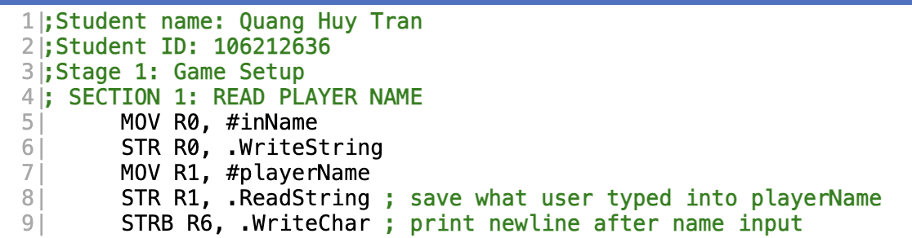

Development Rationale & Architectural Implementation:
In this part of the program, I handle reading the player’s name. First, I move the address of the string inName into register R0 and use STR R0, .WriteString to display it on the screen as a prompt. Then, I prepare a memory space to store the user’s input by moving the address playerName into R1 and using .ReadString to save what the user types.
After the input is stored, I use STRB R6, .WriteChar to print a newline character. I use STRB instead of STR because I only need to output a single character, and STRB ensures that only 1 byte is written without affecting other memory. This makes the output cleaner and prevents any unwanted memory issues.

1.2. Stages 1 & 2: Hardware-Level Validation Loops and APSR Flags
(Reference: Lecture 8.2 Looping and Branching & Lecture 8.3 Conditional Branching)

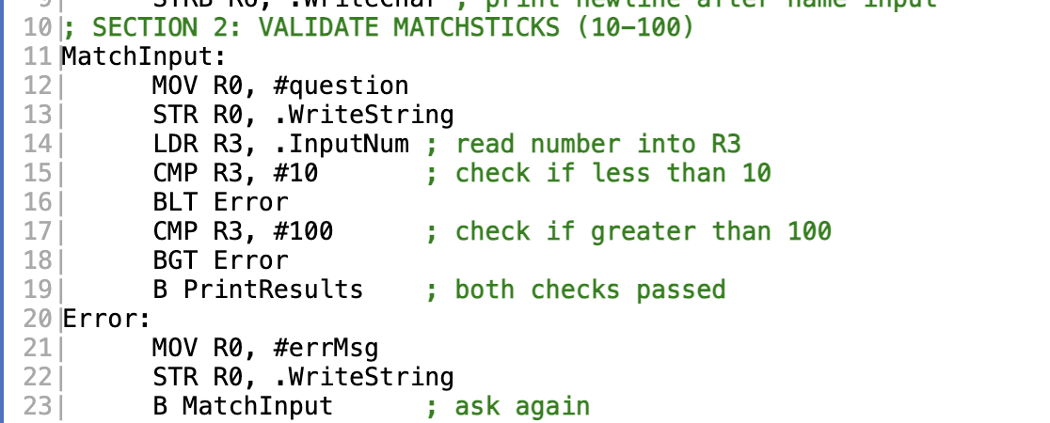

Development Rationale & Architectural Implementation:
In this part of the program, I validate the number of matchsticks (from 10 to 100). The code starts at MatchInput, where I display a question by moving its address into R0 and using STR R0, .WriteString. Then, I read the user’s input using LDR R3, .InputNum, which stores the value in R3.
After that, I check if the number is valid using CMP. First, I compare it with 10, and if it is less than 10, the program branches to Error using BLT. Then, I compare it with 100, and if it is greater than 100, it also branches to Error using BGT. If both conditions are passed, the program continues to PrintResults. In the Error section, I display an error message and use B MatchInput to loop back and ask again, ensuring the user can only proceed with a valid input.

1.3. Stage 2: Arithmetic State Management & Underflow Protection
(Reference: Lecture 7.3 Some Programming Basics & Lecture 8.2 Looping and Branching)

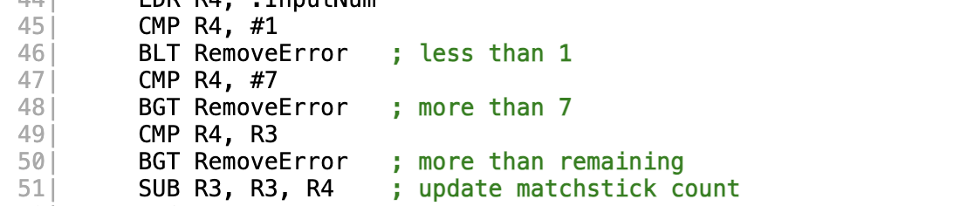

Development Rationale & Architectural Implementation:
In my program, I used register R3 to store the total number of matchsticks remaining, so it acts like the main game state. Register R4 is used to temporarily store how many matchsticks the player wants to remove in each turn.
Before actually updating the number of matchsticks using the SUB instruction, I added several checks to make sure the input is valid. One important check is CMP R4, R3. This step is really necessary because it prevents an error where the player tries to remove more matchsticks than what is left.
For example, if there are only 3 matchsticks left but the player tries to remove 5, without this check, the SUB instruction would make R3 become a negative number. This would break the game logic, since the game is supposed to stop at 0, not go below it.
So, I used a branch instruction to jump to an error message if R4 is greater than R3. This way, I make sure the game always stays in a valid state and works correctly.

1.4. Stage 3: Pseudo-Random Generation via Bit-wise Masking
(Reference: Lecture 9.1 Bit-wise Operations)
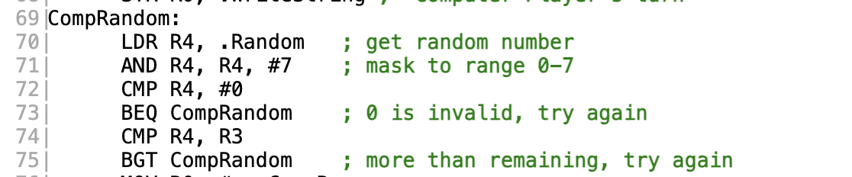
Development Rationale & Architectural Implementation:
To add a computer opponent, I needed a way to generate random moves. ARMlite provides a .Random value, which gives a random 32-bit number. However, in this game, the computer is only allowed to remove between 1 and 7 matchsticks.
Since Assembly doesn’t have a built-in modulo operator like in high-level languages, I used a different approach. I applied a bitwise AND operation with the value #7. In binary, 7 is 0000 0111, so when I AND it with the random number, it keeps only the last 3 bits and sets the rest to 0.
This works because 3 bits can represent numbers from 0 to 7, so it quickly limits the random value to that range without needing complex calculations.
However, there is still one problem: the result could be 0, which is not allowed in the game. To fix this, I used the BEQ instruction to check if the result is 0. If it is, the program will generate another random number until it gets a value between 1 and 7.

1.5. Stage 3: String Processing and Indirect Memory Addressing
(Reference: Lecture 9.2 Indirect and Indexed Memory Addressing)

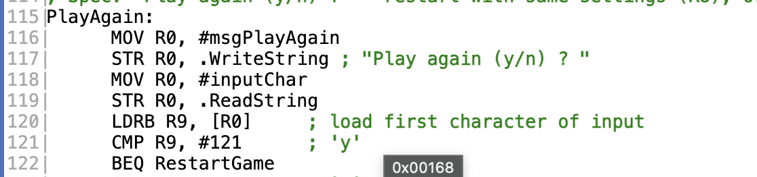

Development Rationale & Architectural Implementation:
When asking the user if they want to play again, I stored their input in a block of memory called inputChar. Instead of writing a long loop to go through the whole string, I used a simpler and more efficient way to read just the first character.
I did this using indirect addressing. First, I put the address of the input into register R0. Then, by using [R0], the CPU treats R0 like a pointer to that memory location. With the LDRB instruction, I can load only 1 byte from that address, which is exactly the first character the user typed.
This is useful because I don’t need the whole string—just the first letter is enough to check if the user wants to continue. After that, I compare this character with its ASCII value (for example, #121 for lowercase ‘y’).
This way, I reduce the number of instructions and make the code simpler and faster, instead of processing the entire input string.

1.6. Stage 4: Framebuffer Coordinate Mathematics via Logical Shifting
(Reference: Lecture 8.4 Low Res Pixel Graphics & Lecture 9.1 Bit-wise Operations)
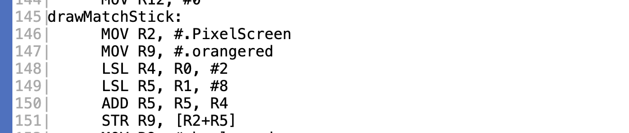
Development Rationale & Architectural Implementation:
In Stage 4, I changed the game from a text-based program into a simple visual one using the ARMlite display. The screen works like a long 1D array in memory, where each pixel takes up 4 bytes. Since the screen is 64 pixels wide, I had to convert (X, Y) coordinates into a memory address to draw on the screen.
Normally, this would use a formula like: base address + (Y × width × 4) + (X × 4). However, multiplication can be slow in Assembly, so I optimized it using shift operations instead.
Instead of multiplying, I used LSL (Logical Shift Left), which is faster:
- LSL R4, R0, #2 means I multiply the X value by 4
- LSL R5, R1, #8 means I multiply the Y value by 256 (because 64 width × 4 bytes = 256)
After calculating the position, I added it to the base address of the screen using indexed addressing ([R2 + R5]). This lets the CPU automatically find the correct memory location.
Finally, I used the STR instruction to write a color value (like .orangered) directly into that memory location, which makes the pixel appear on the screen.

1.7. Stage 4: Context Preservation using the Stack
(Reference: General ARM Subroutine Calling Conventions)

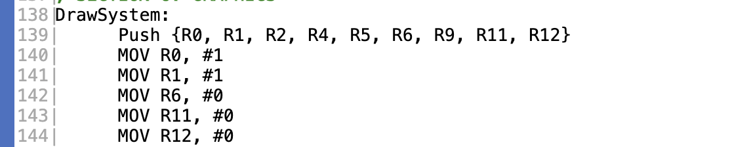

Development Rationale & Architectural Implementation:
The DrawSystem subroutine is quite complex because it uses two nested loops (bodyLoop and newLine) and needs many registers to keep track of things like X and Y positions, loop counters, colors, and memory addresses.
Because of this, I had to be very careful with how registers are used. If these registers were accidentally overwritten, the main game could crash when the program returns from the subroutine, since important values (like the number of matchsticks left) might be lost.
To avoid this problem, I followed the ARM calling convention and used the stack to save and restore register values. At the beginning of the subroutine, I used the PUSH instruction to store the current values of the registers onto the stack. This makes sure all important data is kept safe in memory.
Then, the subroutine is free to use those registers however it wants for drawing. Before finishing, I used the POP instruction to restore all the original values back into the registers.
This way, the DrawSystem works like a separate “black box” — it does its job (drawing graphics) without affecting the rest of the program.

2. Online Resources

2.1. The ARMlite Programming Reference Manual (Peter Higginson, V1.2):
I mainly used this document as my key reference when building the project. It helped me understand important system features in ARMlite, such as .ClearScreen (used to clear the screen before redrawing in Stage 4) and .Random (used for the computer’s moves).
I also used it to manage memory correctly in the Data Segment. For example, I learned when to use .asciz for strings (since they need a null character for .WriteString) and when to use .block to create empty memory space for user input.

2.2. ASCII Character Conversion Chart:
Since the CPU only works with numbers and not text, I used an ASCII chart very often during development. It helped me convert characters into their numeric values so the program could process them.
For example, I needed to know that uppercase ‘A’ is 65 and lowercase ‘y’ is 121 to write conditions that check user input, especially when asking if the player wants to play again.

